Audio Mixing for Interactive Multimedia Communications
Agustín José González and Hussein Abdel-Wahab
Department Of Computer Science
Old Dominion University
Norfolk, VA 23529
gonza_a, wahab@cs.odu.edu

Abstract
Audio is a basic and essential component of many interactive multimedia applications. An example of such an application is the IRI system, developed at Old Dominion University for interactive remote instruction. This paper describes the design and implementation of the audio mixing subsystem used in IRI, which can also be used in many similar applications. Audio mixing is accomplished by using multiple logic queues implemented in a shared buffer that mixes audio streams as they arrive from the network.

Introduction
IRI is an interactive multimedia collaborative system for distance learning developed at Old Dominion University []. It provides a virtual classroom over a high speed Intranet in which individual computer workstations become each student's window into the virtual classroom. It scales in its current version to about 30 workstations distributed over several sites as far apart as 200 miles. The intranet consists of a public ATM network, Sonet channels and 10Mb/s Ethernet. IRI uses IP multicast to send audio data as UDP messages.
Interactive multimedia applications such as IRI need to deal with audio related problems, such as scalability of the number of participants in an audio conference, accumulated end-to-end delay, simultaneous multiple audio sources reproduction, and echo.
Transferring a person's audio, represented as sound waves, to another remote person through packet-based network introduces challenges that did not exist in monolithic, dedicated designs. The communication path cannot be modeled as a dedicated one with a constant transmission delay as in circuit-switched connections. Thus, the large delay variation that may be present in networks with limited or no Quality of Service guarantees can lead to a severe end-to-end delay. Silence detection is one technique used to reduce this delay. Unlike typical streams that occupy a unique position in the spatial/time domain, human beings can make sense of a number of audio signals being played at the same time and place. Thus mixing is required to simulate collocation by playing out multiple audio streams in a single output device.
2. Receiving and Playing Multiple Streams
Computers' audio hardware normally allows only one audio stream to be played at a time, so application-level mixing is required to play audio streams from several users. Figure 1 shows audio conversion from multiple audio streams to sound.
The sound or pressure wave we hear when several audio sources are played in a room is the linear combination of each pressure wave. This means that if active participants in a conference were in the same room, the signal captured by a single microphone would be the linear combination of the signals that participants would generate if they were in separate rooms. This explains why mixing audio streams is the sum of each incoming stream. Let x_{i}(j) be the j^{th} linear sample of the i^{th} continuos audio stream, then the j^{th} linear sample of the mixed stream is given by:
m(j) = ∑ x_{i}(j) (1)
^{i=0..n-1}
The expression for m(j) is the base of any mixing algorithm. The number of audio streams to be mixed, at a given time, changes dynamically as new users activate their microphones, speech is detected, or packets are lost in the network. Thus receivers need to distinguish each incoming stream, to know how long to wait for audio packets before computing the mixed one, and also to take care of the range of the resulting mixed sample.

Mixing Multiple Streams
In this section, we present solutions for the playback synchronization and scaling problems described above. Our algorithm synchronizes the playback with the events coming from the input audio device, every time it accumulates a new packet. We assume the sampling rate of every host is the same, so the audio output device
consumes packets at the same rate the input device generates them. Thus, it is enough if the algorithm writes one packet into the output audio buffer every time it obtains packet from the input audio buffer (microphone buffer), as shown in Figure 2.
If audio streams are coming from different network transport layer connections, the application does not need to implement the queues nor the de-multiplexing module represented in Figure 2. Transport layer queues can be used instead. For example, this is the case of conferencing applications that use point-to-point transport-level connections.
The computation of the mixing buffer is simple from Equation (1). Below is an algorithm to perform that operation.

MixedSample *DequeueAndMixAudioPackets( Queues *Q)
{
static MixedSample mb[P];
Sample in[P];
for (i=0; i < P; i++)
mb[i]=0;
for( i=0; i<N; i++) /* for every queue i */
if (QueueNotEmpty(Q, i) {
Dequeue(Q, i, in);
for ( j =0; j<P; j++)
/* add samples to the mixing buffer */
mb[j]+= in[j];
}
return(mb);
}
We assume that one multicast group is created per conference, like in IRI, so all the streams are coming from a single UDP socket. The algorithm performs de-multiplexing based on the source host IP-address carried in every packet. This information could be retrieved from the network application-programming interface or sent along with each audio packet.
By using a unique multicast group for sending multiple audio streams, the audio component of the system does not limit the scalability of the multimedia application. Figure 2 shows that applications have to de-multiplex incoming streams into an unlimited number of queues. Here, we take advantage of the fact that the number of needed queues is really the maximum number of simultaneous talking participants. In order to map a number of incoming streams into a limited number of queues, we use the less-frequently-used algorithm for paging allocation that is common in operating systems.
Another point in consideration is the size or type of the entries defined for the mixing buffer. The variable type for the entries of the mixing buffer must be chosen such that it does not overflow during the sum of multiple samples. For instance, if one defines it as 16-bit long and the samples are also 16-bit precision, two audio streams could easily overflow some mixed samples and generate distortion in the playback.
Selecting the appropriate variable type for the entries of the mixing buffer does not ensure that the magnitude of the resulting mixed samples fit the range allowed by the output hardware device. The easiest scaling algorithm clips the out-of-range samples to the extreme values. The basic algorithm for scaling down mixed samples is as follows:

DeviceSample * Scaling( Sample *buff)
{
int i, s;
float d=1;
static DeviceSample out[P];

for (i=0; i < P; i++){
s=(int)(buff[i]/ d);
if ( abs(s) > MAX_LINEAR_SAMPLE) {
d= ((float)abs(buff[i]))/MAX_LINEAR_SAMPLE;
if (s > MAX_LINEAR_SAMPLE)
s = MAX_LINEAR_SAMPLE;
else
s = -MAX_LINEAR_SAMPLE;
}
out[i]=s;
}
return(out);
}
In this algorithm, when any sample s exceeds the maximum value for the audio output device, all the samples after s in the same packet are scaled down by a factor d, where this factor is the minimum value that makes s fit in the output device range.
Even though the previous algorithm works, the use of float point operations is expensive and we try to avoid them. Integer operations cannot be used directly because of their precision. In this case, the minimum scaling is by a divisor of 2 or 50%. To provide more control over this factor, we use fixed-point operations of one hexadecimal digit precision. Then, the final version for the scaling algorithm is:
DeviceSample * Scaling( Sample *buff)
{ int i, s;
static int f=16;
static DeviceSample out[P];

if (f < 16 ) f++;
for (i=0; i < P; i++) {
s = (buff[i]*f) >> 4; /* buff * (f/16) */
if ( abs(s) > MAX_LINEAR_SAMPLE) {
f = abs((MAX_LINEAR_SAMPLE << 4) / buff[i]);
if (s > 0) /* clip */
s = MAX_LINEAR_SAMPLE;
else
s = -MAX_LINEAR_SAMPLE;
}
out[i]=s;
}
return(out);
}
Finally, the algorithm for mixing multiple audio packets is as follows:

On receiving an audio packet from the network:
Read_packet(&pkt);
Enqueue_Packet(Q, AllocateQueue(pkt.SourceAddres), pkt);
On receiving a new packet from local audio device :
WriteToAudioOutputDevice (Scaling(DequeueAndMixAudioPackets( Q));

Refinement of Queues Implementation
The algorithm for handling multiple queues described in the previous section does not use the resources efficiently. Most of the time, only one or two queues are in use even though the system holds resources for the maximum number of audio streams. The refinement, illustrated in Figure 3, consists in having a single queue and computing the mixed audio stream as packets arrive.
In this refinement, multiple logic queues are maintained in a unique buffer in memory, and a pointer per logic queue keeps track of the last packet inserted into it. When a packet arrives, it is allocated a queue and then inserted into the position given by the pointer of that logic queue. The insertion process sums the samples of the packet with the mixed packet accumulated so far or writes the packet into the mixing buffer in case it is the longest logical queue.
The function for queuing packets inserts a packet into the logical queue specified by the argument queue and mixes the incoming packet if it does not go to the longest logical queue. It also maintains pointers to the last packet inserted into any logical queue. The detailed code is as follows:
int EnqueueAndMixAudioPacket( Sample * data, int queue)
{
static unsigned int LastPacket[MAX_QUEUES];
/* the last packet received by every logical queue */
int aux,i;

if (tail == 0 )
/*first packet initializes LastPacket array */
for (i=0; i < MAX_QUEUES; i++)
LastPacket[i]=-1;

LastPacket[queue]=MAX((LastPacket[queue]+1), head);
if (LastPacket[queue]==tail) {
/* Is it the longest logical queue? */
if ( QueueSize==MAX_QUEUES ) {
/* Is the buffer full ? */
LastPacket[queue]--;
/* do not include this packet, dump it */
return(0);
}
QueueSize++;
aux = (tail%MAX_QUEUES)*P;
/* compute position into the circular mixing buffer */
for ( i=0; i< P; i++) {
/* the longest queue, so copy packet at the end */
MixBuff[aux+i]=data[i];
}
tail++;
}
else { /*It is not the longest, so add samples with accumulated so far (mixing). */
/* Compute position into the circular mixing buffer */
aux = (LastPacket[queue]%MAX_QUEUES)*P;
for ( i=0; i<P; i++)
MixBuff[aux+i]+=data[i];
/* add samples to the mixed packet */
}
return(1); /* OK */
}
The function for removing mixed packets from the head of the mixing buffer can be implemented as follows:

int DequeueAudioPacket(Sample buff[] )
{
int i, aux;

if ( QueueSize == 0 )
return (0);
aux = (head%MAX_QUEUES)*P;
for ( i=aux; i < aux+P; i++)
buff[i-aux] = MixBuff[i];
QueueSize --;
head++;
return(1); /*OK */
}
Finally, the refined algorithm for mixing multiple audio packets is as follows:

On receiving an audio packet from the network:
Read_packet(&pkt);
EnqueueAndMixAudioPacket(pkt.data, AllocateQueue(pkt.SourceAddres));
On receiving a new packet from local audio device:
if( DequeueAudioPacket(buff))
WriteToAudioOutputDevice(Scaling(buff));

Conclusions
Audio is the most important component of most interactive multimedia applications. This paper describe the fine details of audio processing and novel techniques used in connection with IRI, an on-going Interactive distance learning project at Old Dominion University.
The quality of the system as perceived by the students largely depends on the quality of the audio system. Therefore, the fine tuning of the audio system to avoid echo and feedback, an automatic gain control, and adaptive silence detection are essential for the success of the IRI project.
An efficient audio mixing technique is essential to support multiple audio stream reproduction. Our approach is based on a single mixing buffer that holds multiple logical queues. Audio packets are assigned to these logical queues and mixed into a mixing buffer as they arrive. The mixed samples are scaled down to fit the output audio device range. The mixed packets are played back at the same rates the packets are produced by the originating microphones.

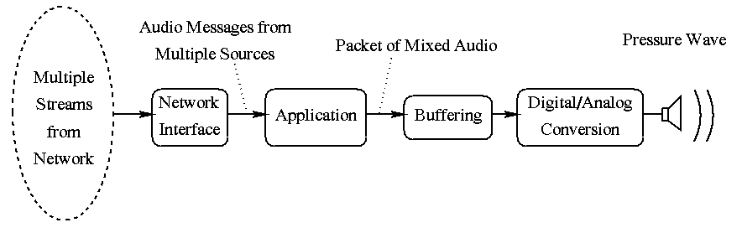
Figure 1. Audio conversion from multiple streams
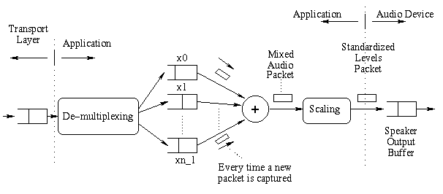
Figure 2. Playback of multiple audio stream
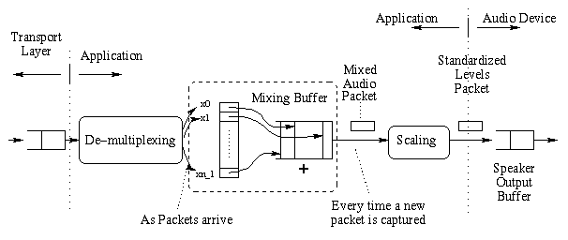
Figure 3. Refinement for mixed audio stream

References

K. Maly, H. Abdel-Wahab, C.M. Overstreet, C. Wild, A. Gupta, A. Youssef, E. Stoica and E. Al-Shaer, Distance Learning and Training over Intranets, IEEE Internet Computing, Vol 1, No. 1, pp. 60-71, 1997.

