Experiences with Structured Recording and Replay in Interactive Remote Instruction

Kurt Maly, C. Michael Overstreet, Agustín González, Michael Ireland, Nilan Karunaratne
Computer Science Department, Old Dominion University, Norfolk, VA 23529-0162 USA

Over the past four years, we have used evolving versions of IRI (Interactive Remote Instruction), a computer-based system to support distance education, to teach a variety of semester-long regularly scheduled for-credit classes. These classes are at sites up to 320 km apart. In this paper we give a brief description of IRI, some initial evaluations of its use, and describe the architecture used to support recording of class activities for future replay, and describe the interface which can be used to steer an IRI replay session.

KEYWORDS: DISTANCE EDUCATION, MULTIMEDIA SYSTEMS, WEB-BASED APPLICATIONS

Introduction

Over the past four years we have used IRI (for Interactive Remote Instruction), a system that we are developing, to deliver regularly-scheduled semester-long (15 weeks) credit classes, starting with one course in the fall 1995 semester to three courses during the spring 1999 semester.

IRI is based on the concept of a highly interactive virtual classroom where students at different locations can have a shared synchronous class experience. Class members (students and instructors) use individual networked multimedia to communicate with each other through video, audio and tool sharing. In addition to its multiway video conferencing capabilities, IRI includes collaboration tools so any class member can take control of a tool for demonstrations or to ask questions at any time, Web-based tools, exam tools, and tools for lesson planning, among others; see [1] for a more complete description. While IRI is a research project, its continual use in real classes with real students and instructors has forced us to address issues of identifying appropriate functionality, providing acceptable performance, and building a reliable system.

Two widely used distance learning methods are TV-based and Web-based courses [2]. In the first method a course is transmitted to remote sites. In Web courses, material is placed in a multimedia, hyper-linked format which students can access through the Internet at any time. Many such courses allow students to interact with the system for progress assessment or to execute tools for acquiring skills. In their pure form the two approaches are on opposite ends of a synchrony scale. TV courses have added asynchronous capabilities by providing videotapes of a lecture that can be viewed at any time. However, tapes do not provide an index that enables students to navigate the material easily. Web courses can provide excellent maps of their contents and are ideally suited for review at one's own pace and abilities. But much of the dynamics that can occur among people in a classroom is difficult to replicate in Web courses. Another disadvantage of Web courses is the high cost to create a good one. It may take $100,000 and six months for a team of Web experts, content providers, and graphics designers to put together an effective course. In rapidly changing disciplines keeping content current is problematic. Regardless of discipline, the rapid improvement of content delivery technologies also makes material obsolete quickly.

A central emphasis in IRI is support for multiple forms of interaction: instructors with students, students with instructors, students with each other, students and instructors with course materials; we believe the ability to encourage and facilitate these multiple interactions is the key contribution of IRI.

In this paper we describe how IRI can be used for both synchronous and asynchronous participation. During a class, IRI records all audio and video, who speaks, whose video is shown and what tools are running when. The concept is simple: during a synchronous session, all individual streams of actions are recorded along with timing indications. This information is synthesized into a set of Web pages that can be used at a later time by a class member to review any portion of the lecture using the Web navigation pages as an index to all class activities. We believe this approach combines key features of TV and Web-based methods. Section 2 presents preliminary results on class members’ perception of the degree of interaction which occurs in IRI compared with other instructional modes. In Section 3 we describe the architecture of IRI’s recording software; Section 4 presents the interface for recording and replay; Section 5 the software architecture of the record/replay interface. Section 6 concludes with comments about status and future work.

Enhancing Interaction

It is axiomatic that proximity in interpersonal communication enriches interaction. Shale et al. [3] state that “in its most fundamental form education is an interaction among teacher, student, and subject content.” All distance education transactions lie somewhere on an interaction continuum, with learner-instructor interaction at one end and learner-content interaction at the other. Computer-based instruction interposes this entire continuum and acts as a conduit that molds the interaction that must pass through it. This molded interaction is key to effective learning and information exchange as it attempts to simulate proximity. Moore et al. [4] consider this type of interaction a defining characteristic of all distance education. Increasing the fidelity of the distance learning environment interactivity generally increases effectiveness and satisfaction and is essential for the student to remain interested and steered toward success [5].

One on-going IRI activity is the search for reliable methodologies to measure the benefits of IRI and similar technology-rich environments. Because of the key role we believe interaction should play in the educational process, our first efforts are to measure students’ perceptions of the degree of interaction when using different delivery technologies. This study includes both cross-sectional and longitudinal assessments utilizing semantic-differential survey instrumentation results of student participants in traditional and two mainstream distance learning environments. Ultimately we wish to determine whether a heightened level of individual interaction--as perceived of learners--actually leads to more satisfaction. This study endeavors to find evidence as to whether pedagogical concepts based on the collective group experiences found in two-way audio, on-way video television classrooms that stress high levels of overall interactivity are misplaced in light of the newer methodology of computer-based distance learning.

While this analysis is preliminary, we find the results shown in Table 1 encouraging. We used survey instruments to gather data comparing class members’ perceptions of individual interactivity. When comparing perceptions of IRI learners, with two-way audio, one-way video television learners, and traditional classroom learners, the perception of classroom interaction of the IRI group is consistently higher suggesting that the increased individual interactivity sought for actually exists. The low perception of interaction reported for traditional classes is interesting and may be due to the large class size (over 70). If further data substantiates this, it may indicate that systems like IRI, which give students more control of their learning environment, may have additional unanticipated benefits.

Table 1: Perceptions of Individual Interaction in Traditional and IRI Environments
Instructional Vehicle | Mean | Standard Deviation | Sample Size
Computer-Based Instruction (IRI) | 3.10 | 0.80 | 54
Traditional Instruction | 2.42 | 0.97 | 24
Two-Audio, one-way Television Instruction | 2.68 | 0.97 | 33

Recording Architecture

In [6] we proposed the architecture for recording based on a simple concept: we include an additional passive “participant” in a session and that participant records and can play back on demand a previously recorded session. By providing a physical machine for this rec/rep participant we do not increase the load on the system as long as that machine is its own file server. This architecture also has the great advantage of enabling us to mix a live session with recorded sessions. A group of students can have a live IRI session and a leader can use a steering applet to select, start and as desired stop a recorded session. At the same time live participants, though geographically dispersed, can listen and watch, as well as speak to and see remotes students since they can replace a recorded video with their own live image. After significant use in real classes, the effectiveness of this design has been demonstrated.

Our initial use of recording for live classes started in the spring 1999 semester in three courses. Depending on the class activities, an hour of recording takes anywhere from 300MB to 1 GB with most disk space taken by the teacher/presenter’s video.

So far we have only limited data on how students will use recording and replay; current use has been limited to students replaying class sessions they missed. As described in Section 4, we have provided an navigation system that is intuitive, stopping is instantaneous, and the time required to restart of the session at another point is on the order of half a second (not counting the first time tools are brought up). We have used recording/replay extensively in demonstrations where people are fascinated that we can have two sessions simultaneously where in one we play back what just happened in another session. We believe these features enable entirely new ways of learning. Additional experience in the use of replay by both students and teachers will provide a basis for determining what is most useful for what type of student for what type of course.

IRI Session Recording and Review

IRI session recording and review are completely controlled through Java applets by either the session leader or monitor. These options are integrated into regular sessions and are presented to these users on IRI Control Panel interface, as shown in Figure 1. This Web-based interface comes up automatically in every group session. In addition, single users can reach this interface from regular Web browsers for session review in stand-alone mode (an option under Offline Activities). For large sessions, recording is normally controlled from a monitor machine, so the session leader (usually the teacher) can concentrate on human-to-human interaction in this virtual classroom. The recording interface depicted in Figure 2 lets a user select the streams to be recorded and decide when to start or stop recording. We can record three video streams at 10 frame per second (fps) each, the browsable site video at 2 fps, a single audio stream that contains the overall audio of the virtual classroom, and the most relevant activities within our slide show tool.

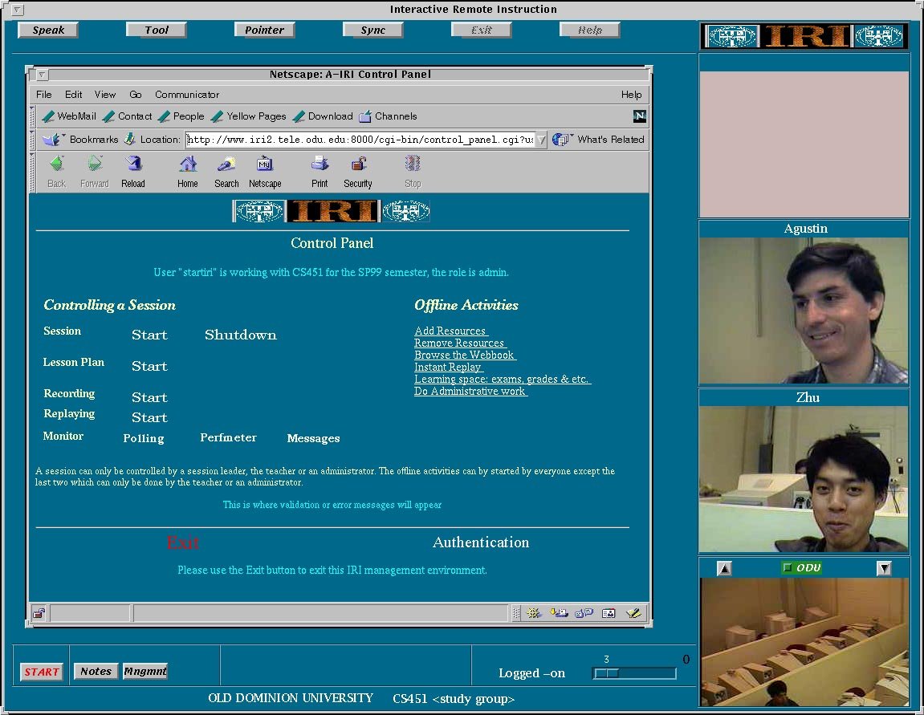
Figure 1: IRI Control Panel in a session
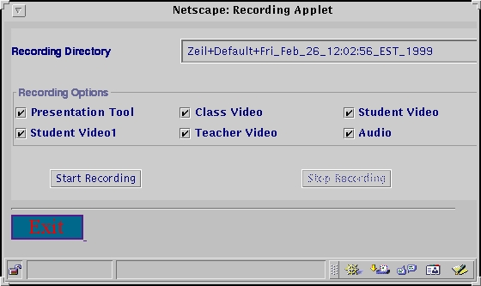
Figure 2: Recording Applet

From a user’s point of view, recording is simple because several pieces of information are already defined, such as time, date, and course code. On the other hand, playback is more involved. To start a review session, the user--a student in case of regular classes--must select the course and the recorded class to be replayed, and then control the actual playback. After selecting the class from a Web browser, a student may run a single-user session or a regular session for group or class review. The former case is simple because the system figures out the session configuration and runs it automatically. Either way the IRI review session looks like Figure 1 (with only one video in case of stand-alone mode). Here the student selects the class date and time from the Replay Session Selection applet and the actual replay control applet is launched as shown in Figure 3.

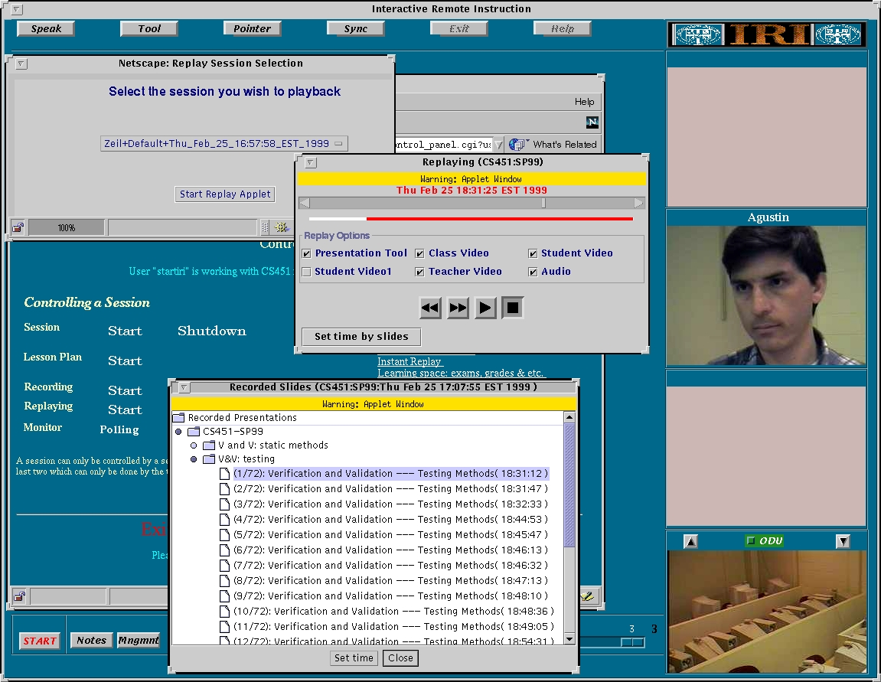
Figure 3: Interfaces for review selection
IRI provides two methods for browsing the recorded data: a time-based scheme with VCR-like controls and a content-based method indexed by the slides described during the recorded class (recorded Slide applet). The time-based scheme also provides a sliding bar for direct setting of the starting time of the replay. Note in Figure 4 a window lists the times the instructor changed slides; this can be used to skip to a particular event in the class to see slides, video and audio from that point. In addition, students can select the streams to be reviewed, so bandwidth consumption and replay server load can be controlled during multiple single-user review sessions, or video spots are made available for live interaction and discussion during group review.

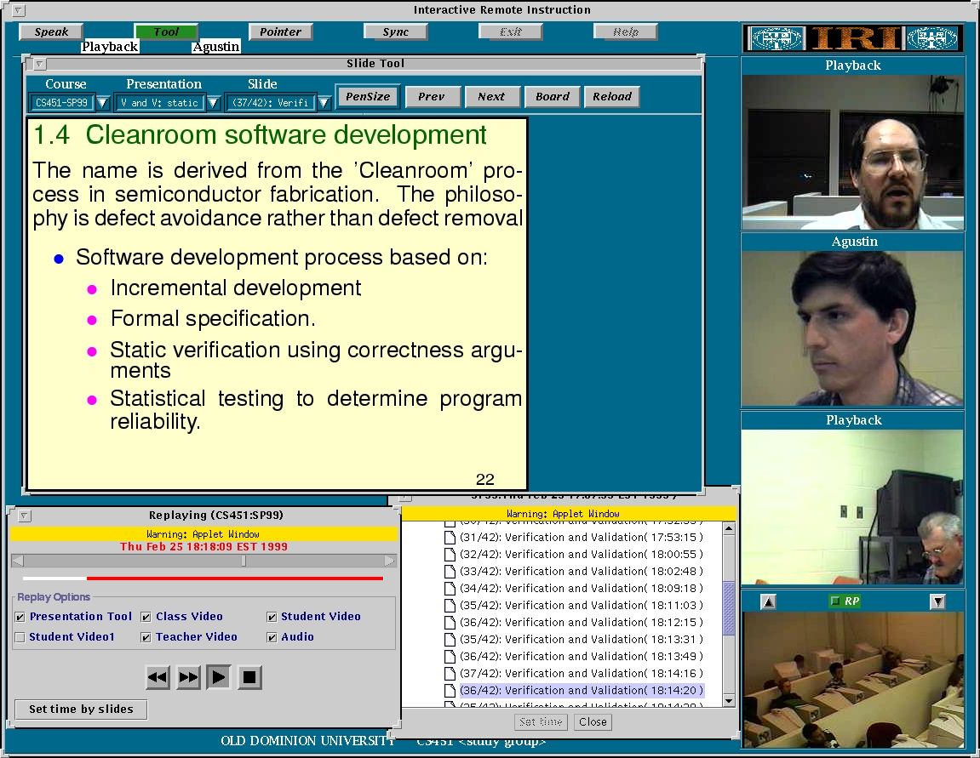
Figure 4: Replay and live session integration

Finally, Figure 4 taken from a real review session where Agustin (identified by the text label over his live video image) is the live user controlling the playback and all the other videos are being replayed (and are labeled “Playback” for class members or “RP” for a replaying site to identify them as recorded rather than live). The site video shows a Norfolk site during the CS451 class, spring 1999. The teacher, in Virginia Beach site (30 km from Norfolk), occupies the video in the upper right corner, and the other video is from a student in Blue Ridge, Virginia (320 km from Norfolk).

Architecture of Replaying and Recording Controller

The architecture of the replaying and recording controller is shown below in Figure 5.

Figure 5: IRI Recording and Replay Architecture

Client Machine
Java
Applet
Web
Browser

Recording/
Replay
Machine

Web Server
Machine
Recording
Replay Server
Java
Server

As noted in Figure 5, a Java server, running on the Web-server machine, acts as a proxy between the recording/replay applet and the recording/replay server. This proxy is necessary in order to meet the constraint of the Java Security Manager, running on the Web browser, that an applet can only communicate with the host from which it originated. Our recording/replay server is equipped with a 4GB-disk partition mounted directly, so that all writing to the disk is local instead of across a the network. This is acceptable for recording three video streams, one audio stream, and slide presentations in a class running 90 minutes.

Recording a Class

When a class is to be recorded, one of the first messages that the Java server sends to the recording server is the name of the directory in which to write the files. The Java server obtains this directory name by concatenating the teacher's name, the group name, and the time the class was started. The recording server responds with an ACK or NACK depending on if it can write to the specified directory.

Once the class is started, the teacher can record straight through or in blocks. Recording the whole class can be quite storage-intensive as noted above. The teacher can also control which streams are recorded and can modify this choice at any time. While a class is in session, only two messages go between the recording applet and the recording server. The first is simply START_REC followed by the streams to be recorded, and the second message is STOP_REC.

Replaying a Class

When a user wishes to replay a class, she selects which class by means of the replay applet running in her browser. Once the class is selected, she can start the replay of the session. The user can set both the time to start the replay and the streams she wants played back. Thus, again there are two messages going between the replay applet and the replay server. The first message indicates at what point in the recorded class the user wants the replay to start. The format of the message is then the time to start the replay (in milliseconds from the time the recorded class was started), followed by the streams to be replayed. The second message is simply STOP_REPLAY, which stops replay of the streams.

Status and Future Work

The current version of IRI is UNIX-based (though we do include Windows NT workstations in class sessions but these machines now require a UNIX server). We plan to continue use of this UNIX version of IRI for classes over the next year since through much use and sometimes painful experience it has evolved into a reliable system. As previously mentioned, we fully believe that IRI’s repeated use with different faculty (who use varying instructional styles) and a variety of students (from education, English, computer science and other disciplines) has forced us to deal with real complexities of synchronous distance education rather than unintentionally simplified situations. We are currently designing a platform independent version, Java based, with an emphasis on supporting at-home class members.

As significant new functionality such as recording and interactive replay is incorporated into IRI, we have found that it often takes experience before we understand how students and instructors best use these capabilities. The ability to replay activities and interactions from previous classes has obvious benefits if a student misses a class. However, this replay can also be used by groups of non-collocated students to review material for an exam since they can selectively navigate through the recorded sessions and discuss replay events among themselves. Instructors an also replay activities from previous classes as part of new classes. It is possible that the presentations, open discussions, and interactions of class members--recorded from a previous semester--could be a more effective delivery mechanism than Web-based courses.

References

1. K. Maly, H. Abdel-Wahab, C. M. Overstreet, C. Wild, A. Gupta, A. Youssef, E. Stoica, and E. Al-Shaer. "Interactive Distance Learning Over Intranets." IEEE Internet Computing, Vol. 1 no. 1, p. 60-71, 1997.

2. E. Fox and L. Kieffer, "Multimedia Curricula, Courses and Knowledge Modules." ACM Computing Surveys, 27(4):549-551, Dec. 1995.

3. D. Shale and D. R. Garrison. In Education at a Distance, D. R. Garrison and D. Shale (Eds.). Malabar, FL: Robert E. Krieger Publishing Company, 1990, pp.1-6.

4. Moore, M.G. and Thompson, M.M., with Quigley, A. B. Clark, G.C. and Goff, G.G., The Effects of Distance Learning: A Summary of the Literature, (Research Monograph No. 2). University Park, PA: The Pennsylvania State University, American Center for the Study of Distance Education. (ERIC Document Reproduction Service, No. ED 330 321), 1990.

5. C. D. Wetzel, P. H. Radke and H. W. Stern, "Instructional Effectiveness of Video Media." Hillsdale, NJ: Lawrence Erlbaum Associates, Publishers. Keegan, 1994.

6. Kurt Maly, C. Michael Overstreet, Agustín González, Melissa Denbar, Roland Cutaran, and Nilan Karunaratne. "Automated Content Synthesis for Interactive Remote Instruction," ED-MEDIA/ED-TELECOM 98, June 20-25th, Freiburg, Germany, 1998.

